Draft Amendment Report. Stonewood Additional 96 Flats. Photograph of site.
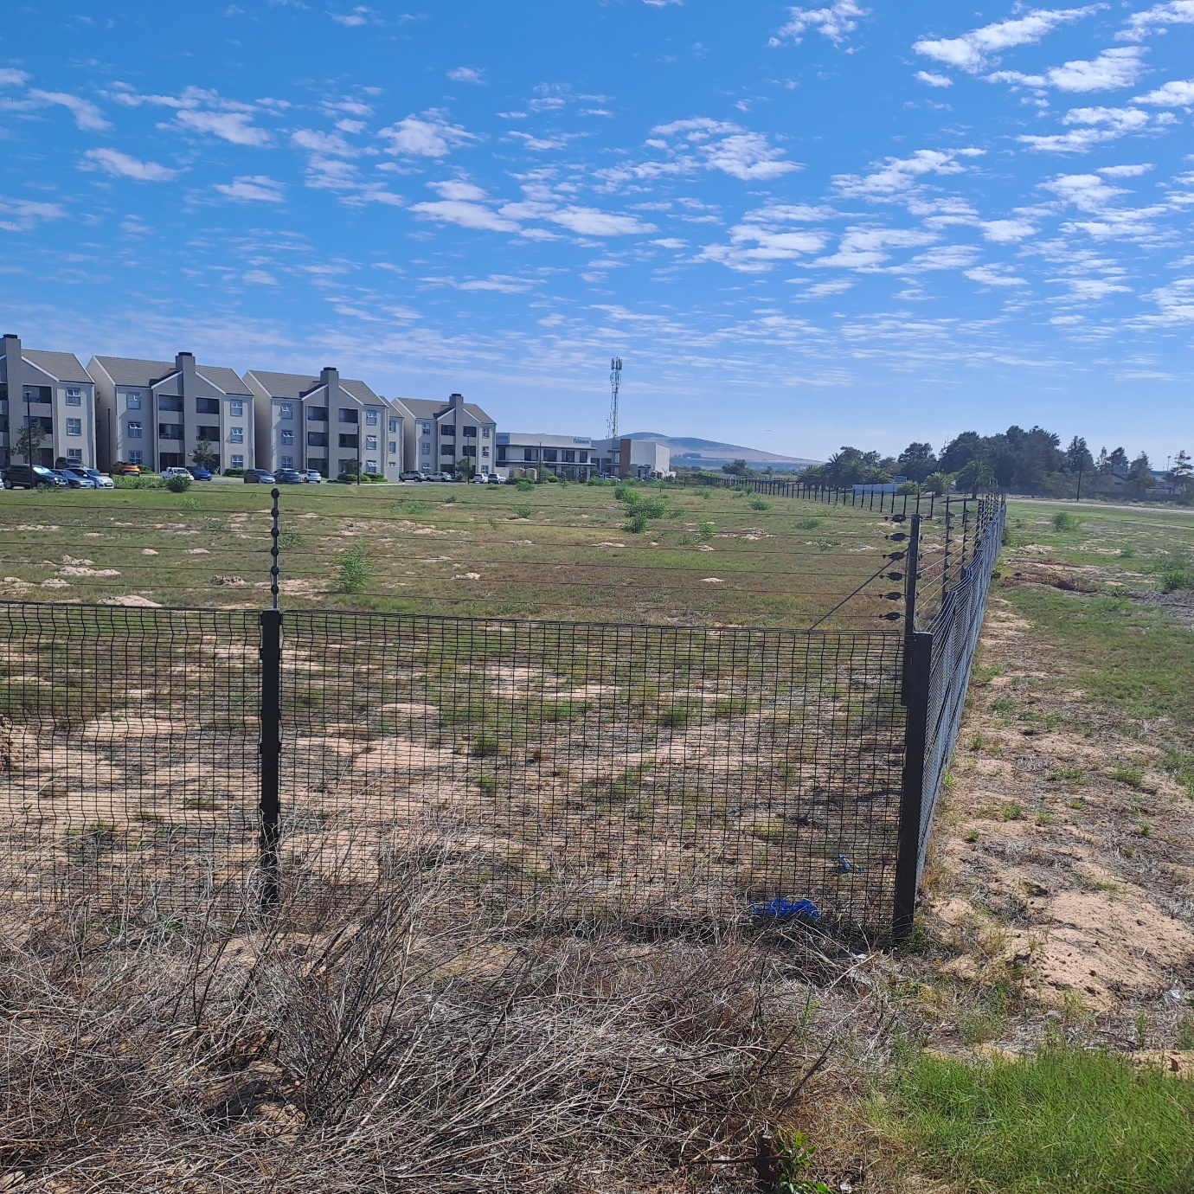
View of site for the proposed additional 96 Flats with existing flats in the background and the Mosselbank River Canal to the right of the estate security fence.

