Photographs of Site for the Proposed Winery
Portion 6 of Farm 550, Stellenbosch

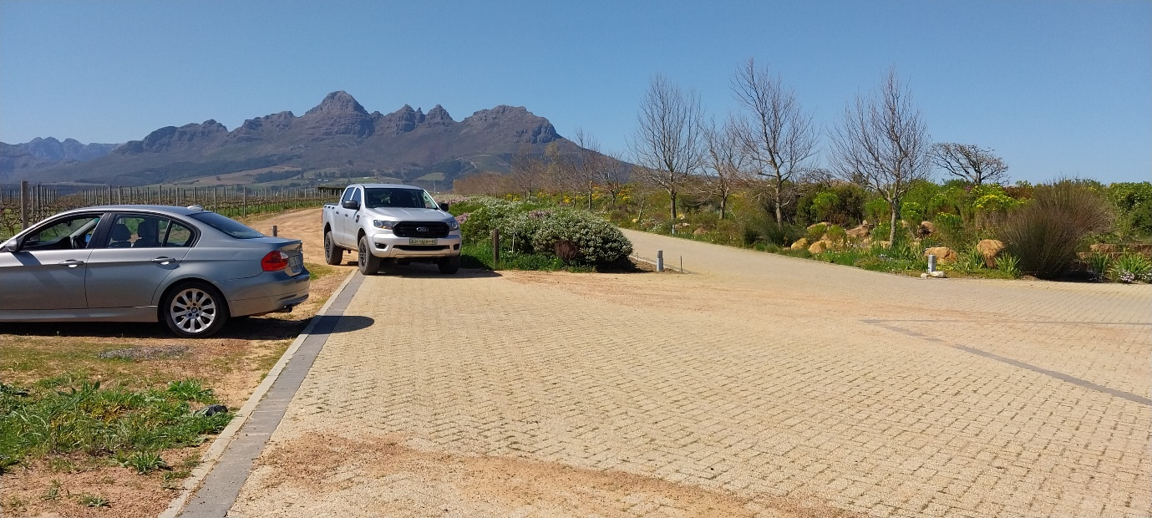
Figure 1: Access to the site is along an existing paved road and an unpaved farm road.

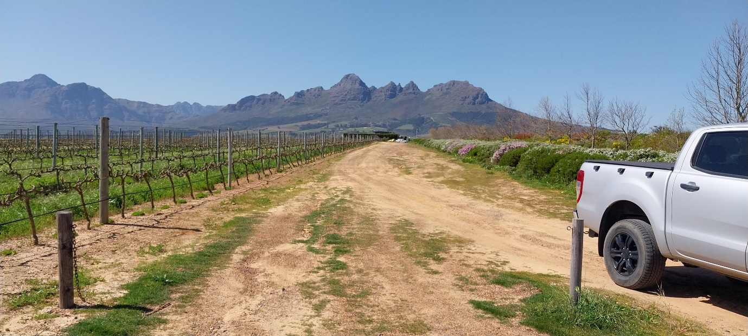
Figure 2: View of the unpaved farm road. The paved road is to the right of the hedge.
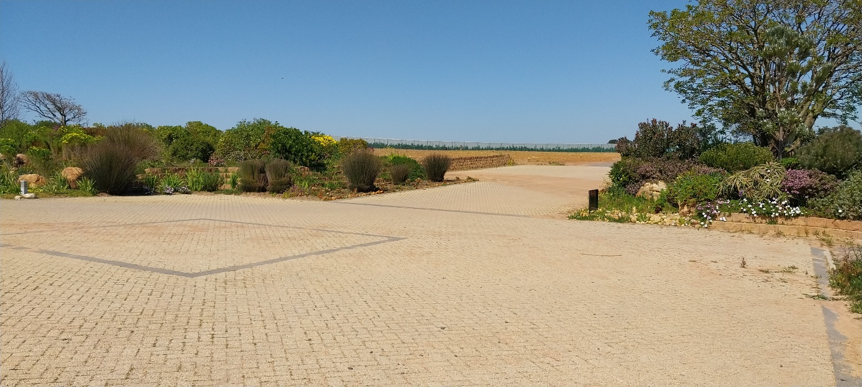
Figure 3: The site for the proposed winery is situated at an intersection of two existing paved roads.

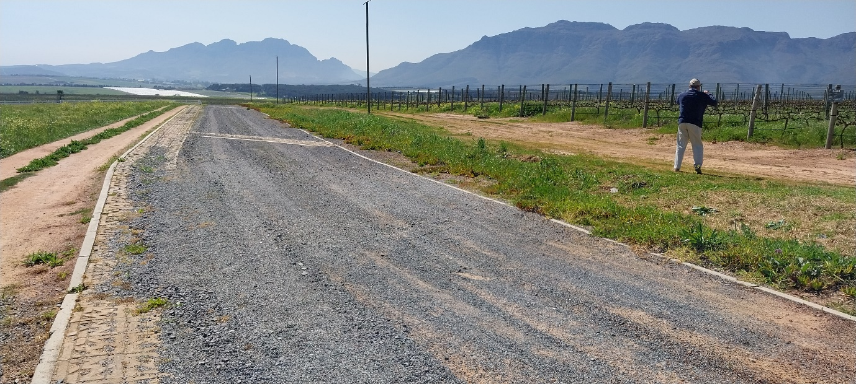
Figure 4 View in a northerly direction from the intersection depicted in Fig 3, of the road to the west of the site.

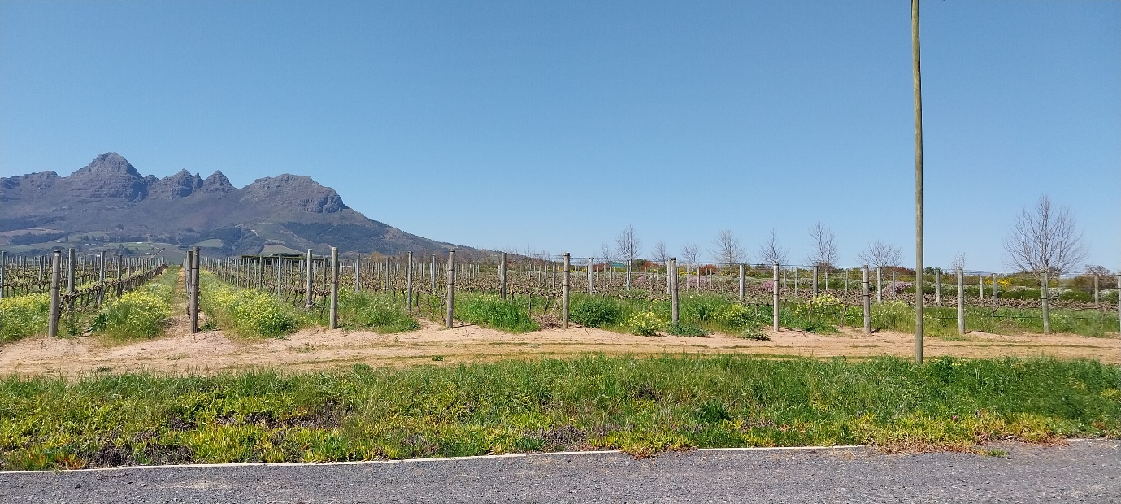
Figure 5: View of site towards the east, comprising of about 10 rows of the vineyard.

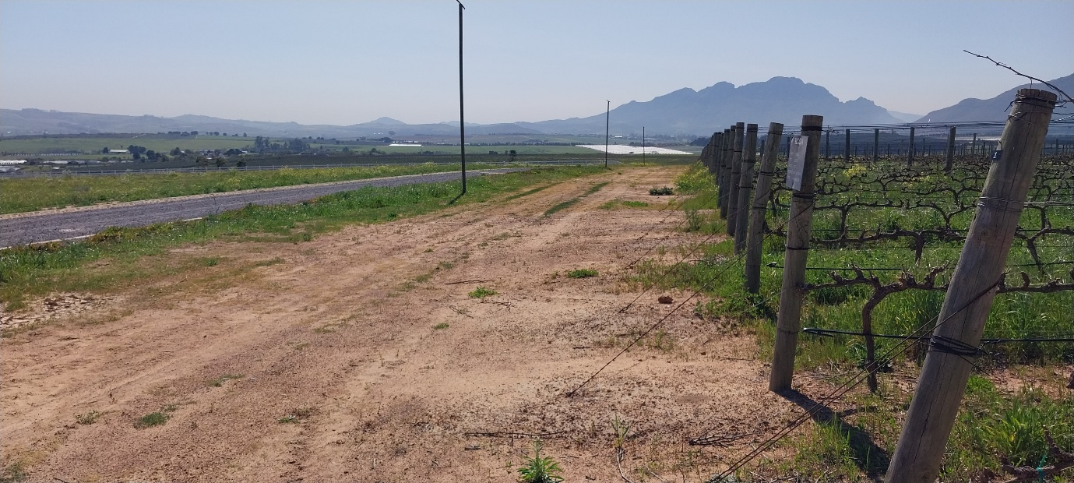
Figure 6: View in a northerly direction showing the corner of the site in the vineyard and the upper road.

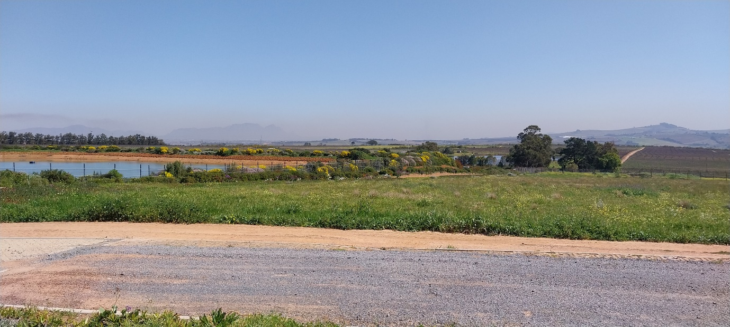
Figure 7: View of the position of the package plant, in a previously cultivated field, with the irrigation dam in the background. The treated wastewater will be piped to the latter.

