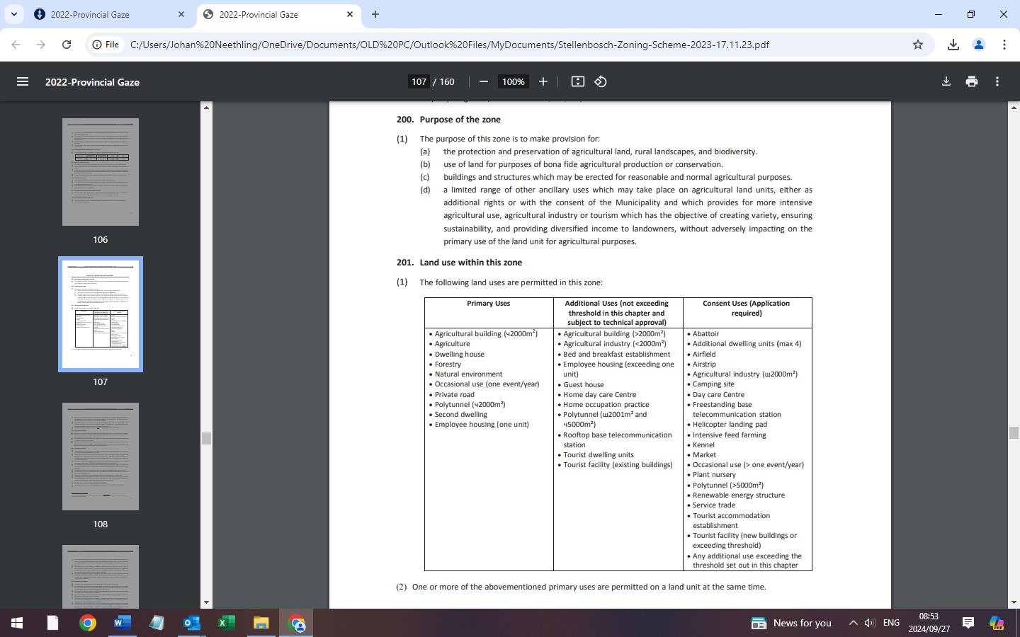
Extract from Stellenbosch Municipal Zoning Bye-law 2019

